### Data Visualization

|  |  |
| --- | --- |
| Date | 24 may 2023 |
| Team ID | NM2023TMID03058 |
| Project Name | Estimation and prediction of hospitalization and medical care costs |

### Data Visualization

Data visualization is the process of creating graphical representations of data to help people understand and explore the information. The goal of data visualization is to make complex data sets more accessible, intuitive, and easier to interpret. By using visual elements such as charts, graphs, and maps, data visualizations can help people quickly identify patterns, trends, and outliers in the data.

### Activity 1.1:  Average Age of Male and Female

### The number of unique visualizations that can be created with a given dataset. Some common types of visualizations that can be used to analyse the medical care costs data include bar charts, line charts, heat maps, scatter plots, pie charts, Maps etc. These visualizations can be used to compare performance, track changes over time, and show distribution, and relationships between variables.

### 

### Activity .2:  Bmi of a person by age

### 

### Activity 3: Number of children by age and smoker

### 

Activity 4. The average age of people according to their region and gende

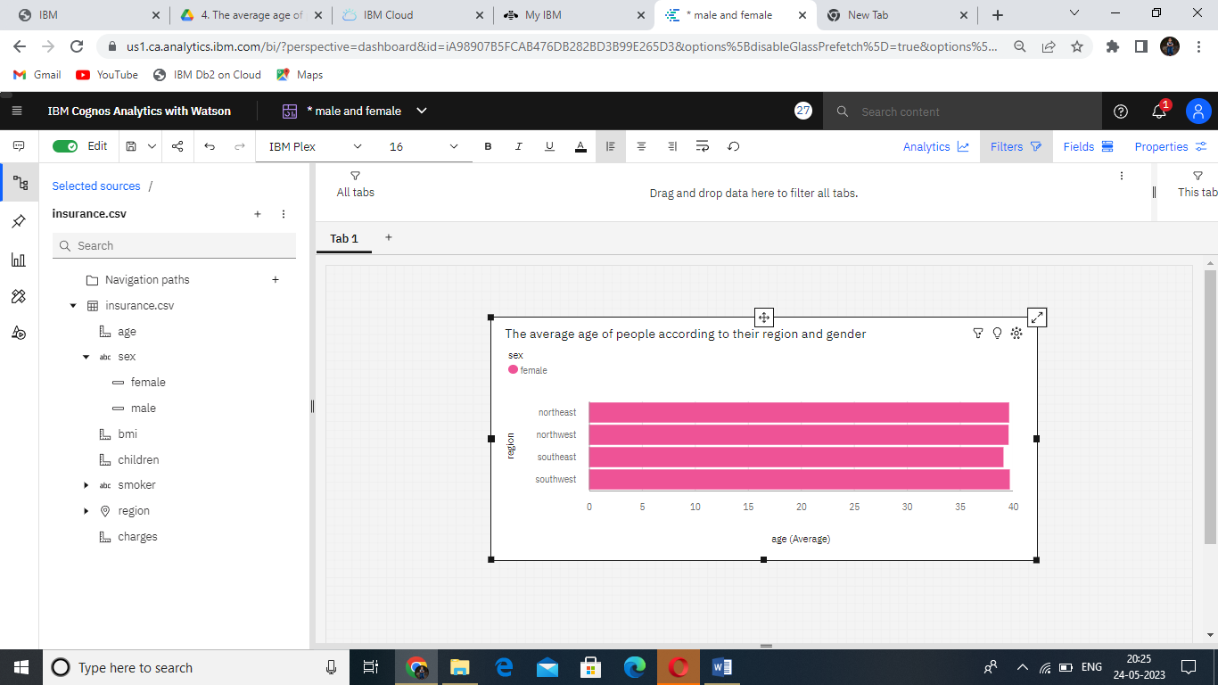

Activity 5. Charges paid by people according to their age and smoker

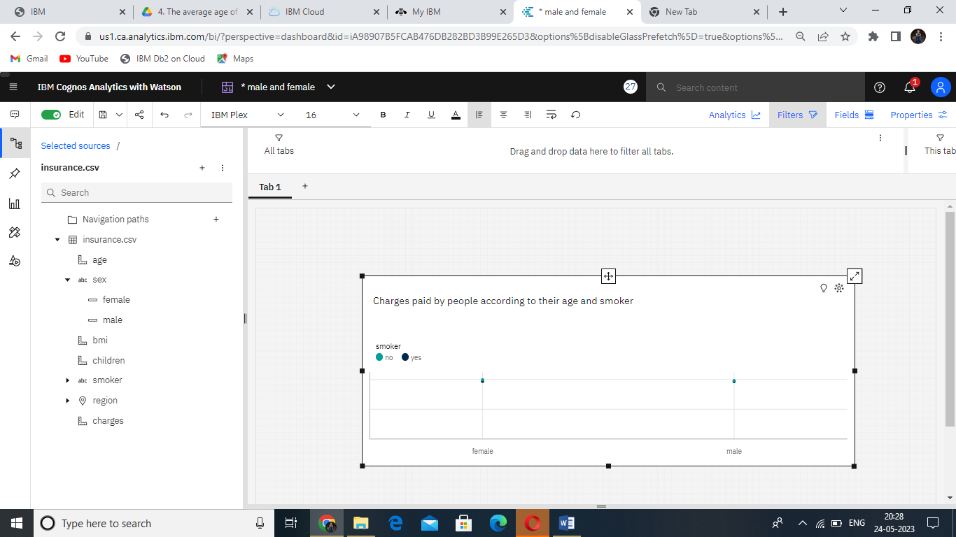

6.BMI of a person by their gender and smoker

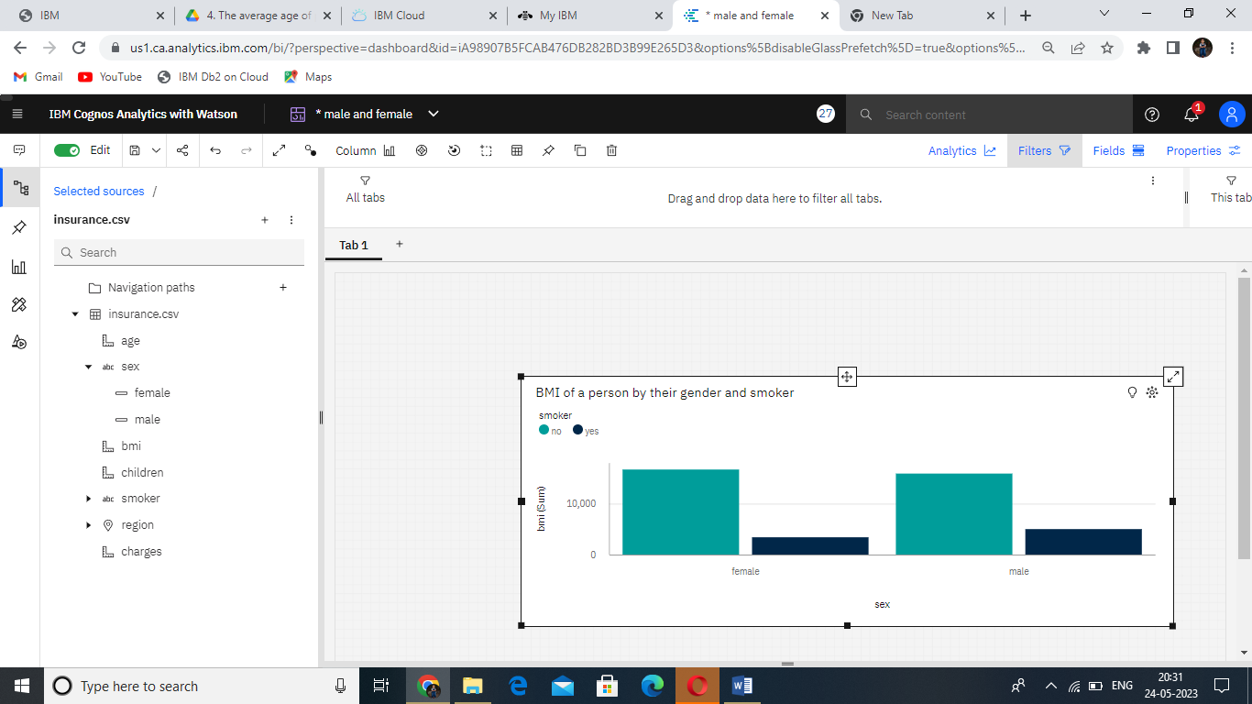

7. Charges paid by people according to their gender, region and smoker

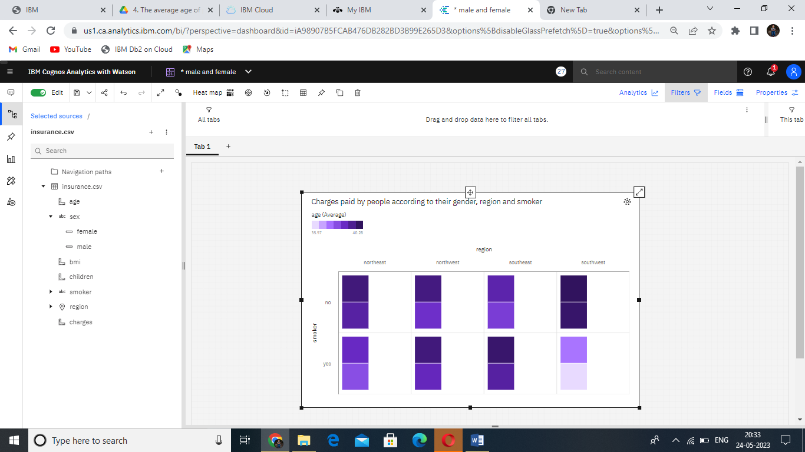

8.Average BMI of people by gender and region

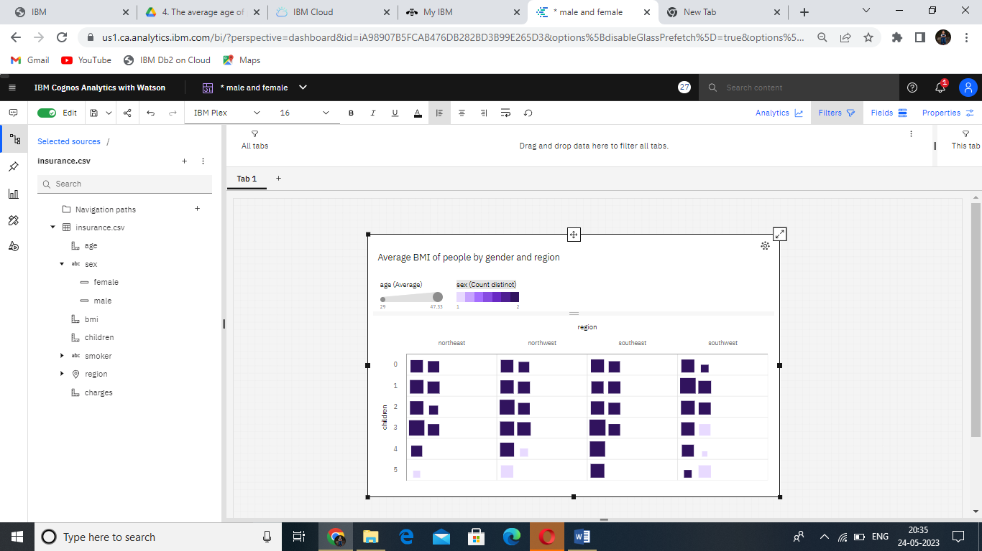

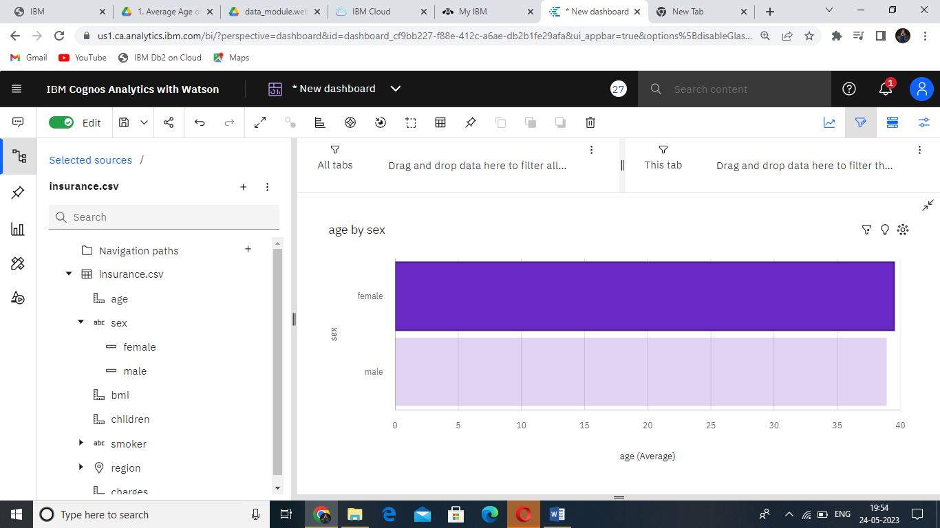

9.Charges paid by the people by region

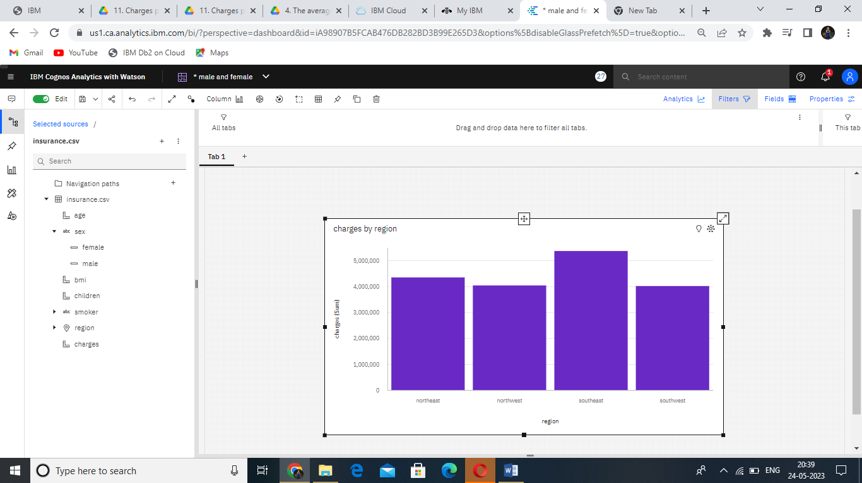

10. 100 charges paid by people based on BMI and coloured by region

